This report will discuss the design and functionality of the bookstore ordering system.
CSY1020 PJ1 Report
Reem Elsaadany – 22851131
Reem.elsaadany23@my.northampton.ac.uk
Table of Contents
1. Video Demonstration: 2
2. Checklist of implemented functionality: 3
3. Design 4
3.1 UML Class Chart 4
3.2 Wireframes 5
3.2.1 Layout Wireframe 5
3.2.2 Adding Object Wireframe 6
3.2.3 Searching Wireframe 7
4. Implementation 7
4.1 Adding objects 7
4.2 Placing orders 11
4.3 Searching for an invoice 13
4.4 Menu bar functions 15
5. Reflection 18

Video Demonstration:
Video demonstration URL:
https://mymedia.northampton.ac.uk/media/BOS+showcase+Reem+Elsaadany+CSY1020/0_103m8ef9

Checklist of implemented functionality:
Checklist for PJ1:
0% to 49% (D Grade)
Customer Records
- Add a new customer | ☒
- Display all customer records | ☒
Book Records
- Add a new book to stock | ☒
- Display all book records | ☒
Place an order by selecting a customer and book | ☒
Display a simple invoice showing customer, book, and total price | ☒
50% to 59% (C Grade)
Shipping
- Option to add shipping to order | ☒
- Calculate shipping costs along with total price | ☒
- Toggle for urgent shipping | ☒
Invoices/Receipts
- Display all invoices/receipts in the system | ☒
- Display individual invoices/receipts | ☒
60% to 69% (B Grade)
Search for invoices by a number (ID) | ☒
Validation
- Input validation when creating customer records | ☒
- Input validation when creating book records | ☒
- Input validation when creating order records | ☒
- Clear error messages using message boxes or labels | ☒
Prevent Invalid Operations
- Cannot place an order if no customers exist | ☒
- Cannot place an order if no books exist | ☒
70%+ (A Grade)
Classes
- Single inheritance (e.g. Person -> Customer) | ☒
- Multiple inheritance | ☒
- Encapsulation using getters | ☒
- Encapsulation using setters | ☒
Access modifiers
- Private attributes | ☒
- Protected attributes | ☒
- Private methods | ☐
- Protected methods | ☒
Use of the @property decorator | ☒
Tkinter Layout
- Multi page layout (week 12) | ☒
- Disable buttons until prerequisites are met, for example a book cannot be added until all required attributes have been entered | ☒

Design

UML Class Chart
This subsection will discuss the design of the bookstore ordering system’s classes using UML class charts as visual representation. These classes lay the foundation of the records kept in the system, and how the objects and classes are related to each other. There are five classes in this system, as will be showcased by figure 1:
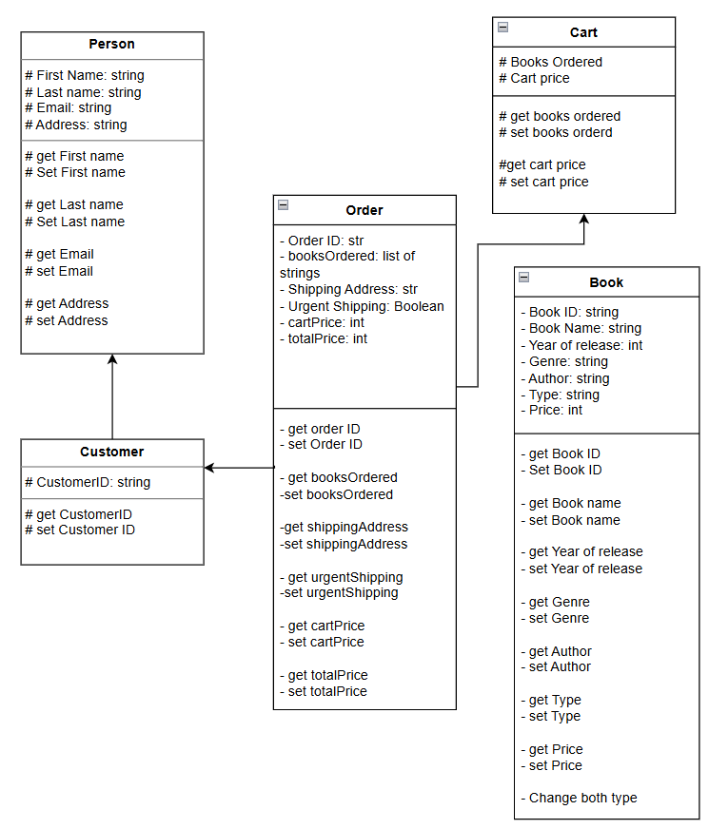
Figure 1
- Book Class, which contains attributes relating to a book object’s ID, book name, author, year of release, genre, type, and price. Attributes and methods in this class are private, which protects the attributes and methods from child classes or outside use.
- Person Class, which is a parent class that contains attributes relating to a person object’s first name, last name, email and address. The attributes of this class are protected, which allows child classes to access them, while protecting them from outside code.
- Customer Class, which is a child class inheriting from Person. This class contains Person’s attributes and methods, along with its own attribute “customer ID”. This class is protected.
- Cart Class, which is a parent class that contains the attributes “Books ordered”, and “cart price”. This class will store the contents of a customer’s cart when they place an order. It is a protected class.
- Order Class, which is a child class that demonstrates multiple inheritance from Cart and Customer. This class contains the attributes of both parents, along with an order ID, shipping address, urgent shipping, and total price. This class has private attributes.

Wireframes
This section will showcase the wireframes used to plan the layout of the program. These wireframes help lay the foundation for the program’s navigation and main contents of key pages.

Layout Wireframe
Figure 2 shows the general layout of the program, which will remain consistent during navigation between different pages.
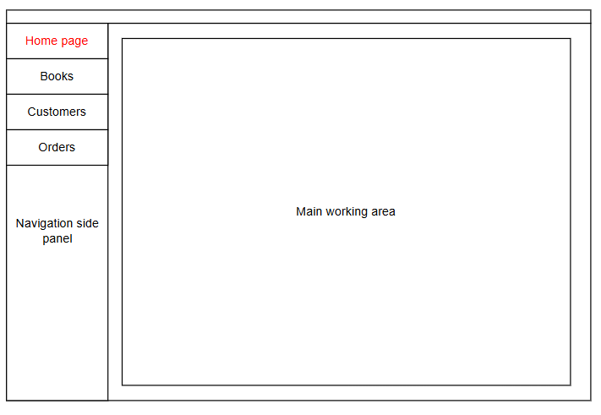
Figure 2
The page is split into two sections, with a navigation side panel on the left, with buttons to navigate between the different pages. The navigation buttons include the home page, books page, customers, and orders, which upon pressing, they display the relevant page on the right side of the screen.
On the right is the main working area, which is where the different pages will be displayed. It occupies around 85% of the window screen, allowing for ample room for the program’s pages. The main working area is the only area of the program that changes between the different pages, which helps maintain a consistent and predictable layout for the user.
At the very top, the page includes a consistent menu bar, which will include all the menus that would assist with performing multiple functions. This program will include functions to create new records, save current records or load previous saves in the file menu, which are essential functions for a records keeping and managing system.

Adding Object Wireframe
The following wireframe will showcase the general layout of an “add object” page:
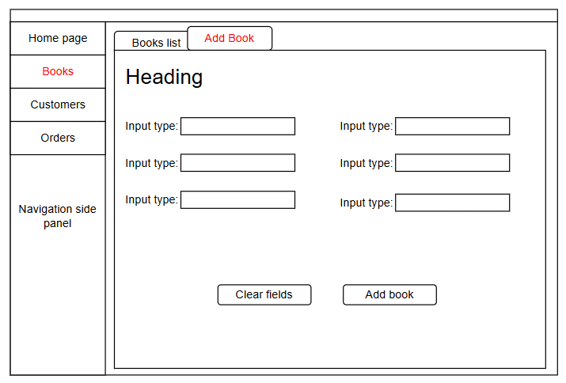
Figure 3
In this example wireframe, the object to be added is a book. Other “add object” pages will follow the same layout, with minor changes depending on the input required by the user.
The “add book" page can be found by navigating to the “books” button on the side navigation panel, then to the second tab in the notebook styled page. The page includes a heading, with a brief description of what the page does, followed by different widgets and labels for each one. These widgets are used for allowing user input, and the widget type will depend on the type of data required. Widgets can be an entry widget, radio buttons, check buttons, combo boxes, or list boxes. Labels help the user identify what input to add and where it should be added. Some widgets will have event bound functions, which will display more fields depending on specific input.
At the bottom of the “add book” page, there are two buttons. The “Clear fields” button allows the user to quickly clear all the entry fields. All the widgets can be cleared using this button. The “add book" button will check the user input for any errors or missing fields, and in the case there are no errors, a book will then be added to the program’s records, which can be navigated to in the first tab of the “books” page. Upon successful addition of the book’s records, the user will receive positive feedback confirming the book has been created.

Searching Wireframe
The following wireframe will outline the layout of the search invoice page:
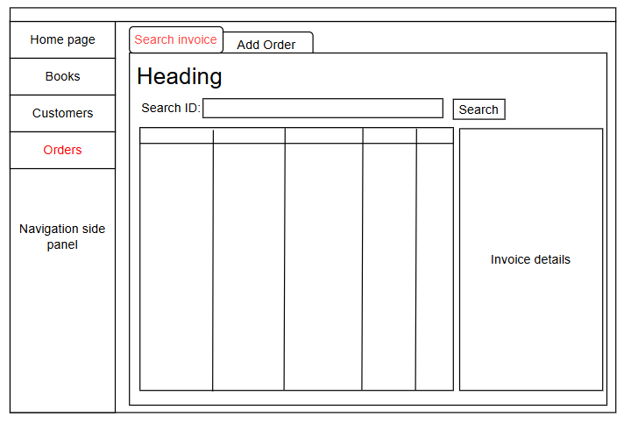
Figure 4
The “search invoice” page can be located by navigating to the “Orders” button in the navigation side panel, and then to the first tab in the notebook styled page. This page includes a heading with a brief description of what this page includes, and below the heading is a search bar which can be used to look for orders with specific ID criteria. The page also includes a list of all the orders in the system, which upon selecting display an invoice showing all the details about the order.
Next to the search bar, there is a button to search for the ID the user wants to find. After filling in the search bar and pressing the button, the list updates with all the orders that match the ID the user searched for.

Implementation
This section will discuss the functionality of this program, which includes snippets of this program’s code, outlining how it works and justifying the reasons for the design.

Adding objects
What each code in this process does:
To add an object to the program, there are dedicated input widgets where the user provides the required input. In this example, the addition of a book object is explained, which is the same process for customer and order objects.
After the user inputs their data and presses the “Add Book” button, the program checks the user’s data for invalid or missing input, creates the new book object and adds it to a dedicated list of book objects, refreshes the treeview list to include the new item, and display a message to provide user feedback. This will be explained below:
def addBookButtonFunctions():
'''this function checks the user's input for error and adds the book to the record if it passed the check'''
book_errors_list = core.checkBookAttributes(new_book_name, new_book_year, new_book_author,genre_combobox, other_genre_entry, new_book_type_selected, new_book_price)

- The program first calls a function “checkBookAttributes” from the core file, which creates a list of possible errors with the input. The function is passed all the relevant input widgets, and return a list of strings which will be used to confirm any errors. The following code showcases this function:
def checkBookAttributes(name_entry, year_entry, author_entry, genre_combobox, other_genre_entry, type_str, price_entry):
'''this function checks the entries of the user to add a book to make sure the input is valid'''
book = {
"name": name_entry.get(), "year of release": year_entry.get(), "author": author_entry.get(),
"genre": genre_combobox.get(),"other genre": other_genre_entry.get(), "type": type_str.get(), "price": price_entry.get()
}
book_errors_list = [] # store a list of all the errors in the entries that the user provided

if book["name"].strip() == '': # if book name is not provided, show an error message
book_errors_list.append("Book name entry cannot remain empty. please input a name.")
elif len(book["name"]) > 150: # if book name exceeds character limit, raise an error message
book_errors_list.append("Book name cannot exceed 150 characters.")

if book["year of release"].strip() == '': # if user did not provide a year of release, raise an error message
book_errors_list.append("Year of release cannot remain empty. please input the year of release.")
else:
try: # if user inputs invalid year, raise an error message
if int(book["year of release"]) < 0 or int(book["year of release"]) > 2026:
book_errors_list.append("Year of release is invalid. Please provide a valid year of release.")
except: # if user input anything thats not an integer, raise an error
book_errors_list.append("Year of release must be a number. Please write the year of release in numbers")

if book["author"].strip() == '': # if the user did not provide an author's name, raise an error message
book_errors_list.append("Book's author cannot remain empty. Please provide the author's name.")
elif len(book["author"]) > 50: #if author name exceeds character limit, raise an error
book_errors_list.append("Author's name cannot exceed 50 characters.")

if book["genre"] == "Select Genre...": # if the user did not select a genre yet, raise an error message
book_errors_list.append("Please select the book's genre.")
elif book["genre"] == "Other" and book["other genre"].strip() == '': # if the user selected "other" genre and didnt specify, raise an error message
book_errors_list.append("Please specify the other genre of the book.")

if not book["type"]: # if the user did not select a book type, raise an error message
book_errors_list.append("Please select the book's type.")

if book["price"].strip() == '': # if the user did not provide a price, raise an error message
book_errors_list.append("Book price cannot remain empty. please provide the book's price.")
else:
try:
float(book["price"])
except: # if the user provided a price that is not a number (or a number followed by symbols), raise an error message
book_errors_list.append("Book's price must be a number. Please provide a valid number without characters or symbols.")

return book_errors_list
the contents of the widgets are stored in a dictionary, and they are then reviewed in a few if statements. If there are any inputs that do not follow a criteria (e.g. price input was not a number, book name was not submitted), a small error message is appended to the errors list after all the inputs have been reviewed, the final errors list is returned to the book_errors_list variable in the GUI file.

- Going back to “addBookButtonFunctions”, the errors list returned is used in an if else statement. If the list is empty, this indicates that there are no errors in the user’s input, and the book object can safely be added to the records.
if not book_errors_list:
new_book_genre = core.otherGenre(genre_combobox, other_genre_entry)
core.addBookObject(new_book_name, new_book_year, new_book_author, new_book_genre, new_book_type_selected, new_book_price)

The functions “otherGenre” and “addBookObject” are called from the core file. “otherGenre” is passed the genre related widgets to return the final genre of the book, and “addBookObject” is passed all the entry widgets and the value from “otherGenre” to finally create the book object. “addBookObject” is showcased in the following code:
def addBookObject(name_entry, year_entry, author_entry, genre, type_radiobuttons, price_entry):
'''this function takes the input from the entry fields and creates a new object with the data'''
global Book_ID
new_book = Book(bookID=f"B-{Book_ID:08}",bookName=name_entry.get(),year=year_entry.get(),author=author_entry.get(),genre=genre,type=type_radiobuttons.get(),price=price_entry.get())
new_book._change_both_type()

books.append(new_book)
Book_ID += 1 # after creating a new book object, increase the book ID variable by 1
In the core file, the variable “Book_ID”, which is used to create the book’s unique identifier, is declared global, to allow modifications to it even outside of the scope of the function. “new_book” is created as an instance of the class “Book” and is passed all the entries required. The method “change_both_type” changes the book’s attribute “type” from “both” to “Physical and Electronic”. Finally, object is added to a global list called “books”, and “Book_ID” is increased by 1.

- In “addBookButton functions, the final step if there are no errors is refreshing the treeview widget and the books listbox (which appears in the add order tab to select books from) to include the book newly added. The contents of these widgets are cleared, and they are re-added from the core’s list “books”. The entry widgets are then cleared to allow for more book creations, and a messagebox appears declaring the addition of the book was successful.
- In case there were strings in the errors list, an error messagebox appears which states all the errors in the user’s input. Each error message gets listed in a numerical list using a generative for loop and the join function.
clearTreeview(book_treeview)
clear_listbox(buy_book_list)
for book in core.books:
book_treeview.insert('', 'end', values=(book.bookID, book.bookName.title(), book.year, book.author.capitalize(), book.genre.capitalize(), book.type, f"£{book.price}"))
buy_book_list.insert(tk.END, f"{book.bookID}, {book.bookName.title()}, {book.year}, {book.author.capitalize()}, {book.genre.capitalize()}, {book.type}, £{book.price}")
bookClearButtonFunctions()
messagebox.showinfo("Success", "The book has been successfully added to the list.")
else:
messagebox.showerror("Incorrect or missing input!", "Please check your input for the following errors:\n\n" + "\n".join(f"{i +1}. {error}" for i, error in enumerate(book_errors_list)))
tk.Button(book_buttons_frame, text="Add book", command=lambda:addBookButtonFunctions()).pack(side='right')

Reasoning for the design:
- Creating a list of strings that includes every individual error, then checking the contents of the string allows the program to be more precise in its error messages. Being more precise about what went wrong in the process or the user’s input will help the user better understand everything that needs to be changed about their input. This is a better alternative than a vague Boolean that displays the same error messages despite varying issues.
- Clearing the contents of the lists and readding the contents after the “books” list has been updated is more convenient than destroying the widgets and recreating them.
- Clearing all the input widgets upon creating a new book prepares them for creating a new book without the need to manually empty their contents. It also serves partially as positive feedback indicating that something has happened upon pressing the button, which is then further affirmed by the success messagebox.

Placing orders
What each code in this process does:
To create an order in the system, the user must input customer and order information and press the “add order" button. The user’s input is then checked for invalidity or missing information and then records of the customer and order are added to their respective lists. This process shares numerous similarities with the process of adding a book to the system, so this section will focus on the differences of this process.
- When selecting a shipping address, the user can choose to keep the shipping address identical to the customer’s address, or add a different address for shipping. This can be done by unchecking the “shipping_checkbutton” widget. After unchecking it, a new entry widget is displayed that allows the user to input the shipping address.
shipping_boolean = tk.BooleanVar(value=True)

def shipping_checkbutton_false():
'''This function shows the user an entry field if they choose to have a different shipping address'''
if not shipping_boolean.get():
shipping_address_label.grid(row=3, column=2, sticky="w")
shipping_address_entry.grid(row=4, column=2)
else:
shipping_address_label.grid_forget()
shipping_address_entry.grid_forget()

shipping_checkbutton = tk.Checkbutton(add_order_tab, text="Shipping address is the same as the customer's address", variable=shipping_boolean, command=lambda:shipping_checkbutton_false())
shipping_checkbutton.grid(row=2, column=2)
shipping_address_label = tk.Label(add_order_tab, text="Shipping address: ")
shipping_address_entry = tk.Entry(add_order_tab, width=50)

- When adding books to a customer’s order, the user can select a book from a list box that displays all the books in the bookstore. This listbox gets updated every time a new book is created along with the book’s treeview list.
tk.Label(order_details_frame, text="Please select the books you would like to purchase:").grid(row=1, column=0)
buy_book_list = tk.Listbox(order_details_frame, width= 100, height=20)
buy_book_list.grid(row=2, column=0)
tk.Label(order_details_frame, text="Books Cart:").grid(row=1, column=1)
selected_books = tk.Listbox(order_details_frame, height=20, width=100)
selected_books.grid(row=2, column=1)
After the user selects a book from the listbox, they can then press the “add book to cart” button, which adds the book to the adjacent list which acts as the customer’s cart. This works by identifying the index of the selected item, and saving its value in a variable. The variable is then inserted into the cart list, and the price of the items in the cart and the total price are updated to match the changes.
def add_selected_book():
'''This function adds the selected book in the books list to the user's cart upon pressing the button, which updates the price labels'''
index = buy_book_list.curselection()

if not index:
return

i = index[0]
book = buy_book_list.get(i)
selected_books.insert(tk.END, book)
core.increase_cart_price(i)
update_price_label(cart_price_label, shipping_price_label,total_price_label)

- When creating an order, the program first calls the functions “check_customer_attributes” and “check_order_attributes” which return their own errors lists. They work identically to “checkBookAttributes”.
def create_order_button():
'''This function checks the customer and order input, showing an error if there are errors, or affirming the success of the operation'''
customer_error_list = core.check_customer_attributes(customer_forename, customer_surname, customer_email, customer_address)
order_error_list = core.check_order_attributes(selected_books, shipping_boolean, shipping_address_entry)
errors_list = customer_error_list + order_error_list
if not errors_list:
core.add_customer_object(customer_forename, customer_surname, customer_email, customer_address)
core.add_order_object(customer_forename, customer_surname, customer_email, customer_address, selected_books, shipping_boolean, shipping_address_entry, urgent_boolean)
clearTreeview(customers_treeview)
clearTreeview(orders_treeview)
for customer in core.customers:
customers_treeview.insert('', "end", values=(customer.customerID, f"{customer.firstName.capitalize()} {customer.lastName.capitalize()}", customer.email, customer.address.capitalize(), ))
for order in core.orders:
orders_treeview.insert('', "end", values=(order.orderID, f"{order.firstName} {order.lastName}", order.shippingAddress, ", ".join(order.booksOrdered), order.urgentShipping, order.totalPrice))
clear_order_details_button()
messagebox.showinfo("Success", "Order and customer successfully added.")
else:
messagebox.showerror("Incorrect or missing input!", "Please check your input for the following errors:\n\n" + "\n".join(f"{i +1}. {error}" for i, error in enumerate(errors_list)))
tk.Button(add_order_tab, text="Create Order", command=lambda:create_order_button()).grid(row=7, column=2)
If the input is validated, the objects are created and the treeview lists are refreshed to reflect the change.
Reasoning for the design:
- Allowing the user to select books from a list to add to a cart allows for flexibility if a customer has ordered multiple books rather than just one.
- Allowing customers to choose a separate shipping address from their home address is a useful feature to have for shipping services.
- The user feedback system when creating orders and customers follows an identical pattern to the process of adding books. Having lists of errors allows for more detailed error messages.
- Creating customer objects during the creation of an order prevents the system from being overridden with customers without orders, which would have no reason to be recorded in the system in that case.

Searching for an invoice
What each code in this process does:
- To search for an invoice, the user can input the ID number of the invoice they would like to find. Then, pressing the “search” button will update the orders list to show only orders that contain the number in their ID.
def search_button():
'''This function searches for Order ID matches and shows them in the treeview'''
search_matches = core.findSearchMatches(search_entry)
The function “findSearchMatches” is called from the core file, which creates a list of all the orders that have an ID that matches the search. This function will be showcased in the following code:
def findSearchMatches(search_entry):
'''this function creates a list of all the objects that match the search criteria'''
id = search_entry.get()
search_matches = []
for order in orders:
if id in order.orderID:
search_matches.append(order)

return search_matches
The main orders list is searched for this ID, by checking each order’s ID attribute. Each matching object is stored in the “search_matches” list, which is returned to the “search_matches” variable in “search_button”.

Then, the orders treeview list is cleared, and the list containing the matches is added instead.
clearTreeview(orders_treeview)
for order in search_matches:
orders_treeview.insert('', "end", values=(order.orderID, f"{order.firstName} {order.lastName}", order.shippingAddress, order.booksOrdered, order.urgentShipping, order.totalPrice))

- To show an invoice’s details, the user can select the order from the treeview list which they would like to see its details. Selecting an order shows its invoice on the right side of the screen.
def selected_order_in_treeview(event):
'''This function changes the invoice details when the user selects an item in the order list'''
order_selection = orders_treeview.selection()
if not order_selection:
return

order = order_selection[0]
order_values = orders_treeview.item(order, "values")
order_ID = order_values[0]

invoice_details = core.show_invoice_details(order_ID)

if not invoice_details:
return

This is done by reading in the order’s ID from the treeview list, which is then used to find the order in “orders”. “show_invoice_details” will be showcased in the following code:
def show_invoice_details(order_ID):
'''This function returns the invoice details of a specific order object'''
global orders
for order in orders: # iterate over each order in the orders list
if order.orderID == order_ID: # if the ID of the current iteration matches the ID of the selected treeview item, return its invoice details
invoice_details = {
"Order ID": order.orderID, "Customer name": f"{order.firstName} {order.lastName}", "Customer email": order.email,
"Customer address": order.address, "Shipping Address": order.shippingAddress, "Urgent shipping": order.urgentShipping,
"Books Purchased": order.booksOrdered, "Price of purchased books": order.cartPrice, "Total Price": order.totalPrice
}

return invoice_details
The order’s details are then saved in a dictionary, and the dictionary is returned to the “selected_order_in_treeview”. The invoice’s details are used to configure the text on the side of the screen, showing the invoice’s details of the selected order. This is shown in the following code:

invoice_order_id.config(text=invoice_details["Order ID"])
invoice_customer_name.config(text=invoice_details["Customer name"])
invoice_customer_email.config(text=invoice_details["Customer email"])
invoice_customer_address.config(text=invoice_details["Customer address"])
invoice_shipping_address.config(text=invoice_details["Shipping Address"])
if invoice_details["Urgent shipping"]:
invoice_urgent_shipping.config(text="Yes")
else:
invoice_urgent_shipping.config(text="No")
invoice_books_purchased.config(text="\n".join(f"{i +1}. {book}" for i, book in enumerate(invoice_details["Books Purchased"])))
invoice_price_of_books.config(text=f"£{invoice_details["Price of purchased books"]}")
if invoice_details["Urgent shipping"]:
invoice_shipping_price.config(text=f"£{urgent_price}")
else:
invoice_shipping_price.config(text="£0.0")
invoice_total_price.config(text=f"£{invoice_details["Total Price"]}")

orders_treeview.bind("<<TreeviewSelect>>", selected_order_in_treeview)

Reasoning for the design:
- Searching for invoices by their ID is reliable since an ID is a unique identifier and no two orders share the same ID. This helps distinguish between orders accurately.
- Binding the selection of an order in the treeview list with the display of invoice details allows for quick swapping of invoices.
- Returning the invoice’s details in a dictionary returns multiple values at once in an organised and easy to work with way.

Menu bar functions
The menu bar has two menus, the file menu, and the help menu. This section will focus on the three core functions of the file menu and explain how they work.
- Create new records
What each code in this process does:
This function clears all the lists and data currently in the program. This is done by changing the values of the ID variables back to 1, and clearing the global records that store objects.
def create_new_record_menu():
'''this function discards previous data and allows the user to start creating new records.'''
user_selection = messagebox.askokcancel("Unsaved Data", "The current records could be unsaved, would you like to create new records?")
if user_selection:
core.create_new_record()
clear_all_data()
First, a messagebox appears asking the user to confirm creating new records. If the user chooses “Ok”, the function “create_new_record” resets all the global variables to their original values. “create_new_record” will be showcased in the following code:
def create_new_record():
'''this function resets the book ID count and removes all the objects in the program'''
global Book_ID, books, Customer_ID, customers, Order_ID, orders
Book_ID = 1
Customer_ID = 1
Order_ID = 1
books = []
customers = []
orders = []
After the values are reset, all the current treeview lists, listboxes, and invoice details in the system are cleared by “clear_all_data”.
def clear_all_data():
clear_treeview(book_treeview)
clear_treeview(customers_treeview)
clear_treeview(orders_treeview)
buy_book_list.delete(0, tk.END)
clear_book_cart()
invoice_order_id.config(text='')
invoice_customer_name.config(text='')
invoice_customer_email.config(text='')
invoice_customer_address.config(text='')
invoice_shipping_address.config(text='')
invoice_urgent_shipping.config(text='')
invoice_books_purchased.config(text='')
invoice_price_of_books.config(text='')
invoice_shipping_price.config(text='')
invoice_total_price.config(text='')

Reasoning for the design:
- Asking the user to confirm the operation before creating new records helps prevent accidental data loss.
- Clearing “buy_book_list”, the book cart, and the invoice details prevents residual data from remaining in the system which could potentially cause errors due to missing data from the main lists.

- Save Current Records
What each code in this process does:
This function saves all the current records’ data in a pkl file.
def save_records_menu():
'''This function saves the current records followed by a message confirming the success of the operation'''
core.save_lists()
The function “save_lists” is called from the core file, which is shown in the following code:
def save_lists():
''' this function saves current data in the records to a pickle file'''
data_to_be_saved = {
"Book ID": Book_ID,
"Books list": books,
"Customer ID": Customer_ID,
"Customers list": customers,
"Order ID": Order_ID,
"Orders": orders
}
with open("Books.pkl", "wb") as f:
pkl.dump(data_to_be_saved, f)
Global variables are first stored in a dictionary. Then, the file “Books.pkl” is either created or opened in “write binary” mode, and the data is stored in that file.
After “save_lists” finished its task, “save_records_menu” displays a messagebox showing that the records have been saved successfully.
messagebox.showinfo("Success", "Saved current records successfully.")

Reasoning for the design:
- Saving the global variables’ values in a dictionary allows the function to save all the program’s data at once, which would also help loading the data later be easier to perform.
- A messagebox confirming that the program has been successfully saved provides positive feedback for the user.

- Load Previous Records
What each code in this process does:
This function loads any previous saves from the file “Books.pkl” if it exists. First, the program tries to call the function “load_lists” from the core file.
def load_records_menu():
'''this function loads an old save of the bookstore's record if it exists, and raises an error if there's no previous save'''
try:
core.load_lists()
“load_lists” then reads in from “Books.pkl” if it exists, and re-assigns the values to the global variables as shown in the code below:
def load_lists():
'''this function loads data from a pre-existing pickle file'''
global Book_ID, books, Customer_ID, customers, Order_ID, orders
with open("Books.pkl", "rb") as f:
loaded_data = pkl.load(f)
Book_ID = loaded_data["Book ID"]
books = loaded_data["Books list"]
Customer_ID = loaded_data["Customer ID"]
customers = loaded_data["Customers list"]
Order_ID = loaded_data["Order ID"]
orders = loaded_data["Orders"]

After “load_lists” completes the function, “load_records_menu” clears all the treeview lists and list boxes in the program and re-adds the loaded values. A messagebox then appears confirming the loading of the previous saves has been successful.
clear_all_data()

for book in core.books:
book_treeview.insert('', 'end', values=(book.bookID, book.bookName.title(), book.year, book.genre.capitalize(), book.author.capitalize(), book.type, f"£{book.price}"))
buy_book_list.insert(tk.END, f"{book.bookID}, {book.bookName.title()}, {book.year}, {book.genre.capitalize()}, {book.author.capitalize()}, {book.type}, £{book.price}")

for customer in core.customers:
customers_treeview.insert('', "end", values=(customer.customerID, f"{customer.firstName.capitalize()} {customer.lastName.capitalize()}", customer.email, customer.address.capitalize()))

for order in core.orders:
orders_treeview.insert('', "end", values=(order.orderID, f"{order.firstName} {order.lastName}", order.shippingAddress, order.booksOrdered, order.urgentShipping, order.totalPrice))
messagebox.showinfo("Records loaded", "Loaded previous save file successfully.")
If there are no previous save files, the program shows an error message that notifies the user that there are no previous save files.
except:
messagebox.showerror("No previous save", "No previous save file found.")

file_menu.add_command(label='Load previous records...', command=lambda:load_records_menu())

Reasoning for the design:
- Clearing “buy_book_list”, the book cart, and the invoice details before loading prevents residual data from remaining in the system which could potentially cause errors or inconsistency due to missing data from the main lists. It also prevents duplication or stacking incorrect values before loading any data.
- A messagebox confirming that the program has been successfully loaded the previous save or declaring that a previous save does not exist provides feedback for the user and eliminates confusion.

Reflection
This assignment helps combine all the lessons from week 8 till 12 and some previous weeks into one big task. It has helped me develop most of the skills that have been taught in the lesson, which is one of the aspects I enjoyed about this assignment. However, my inexperience with GUIs and OOP has caused this to be a challenging assignment. Despite that, with my previous minimal coding experience, I have always wondered how these programs are created and I am satisfied that I now understand more about this style of programming.
I enjoyed the topic of this assignment, and applying my knowledge on a much bigger scale than the exercises practiced in class. I have also enjoyed the satisfaction of finally getting my program to work as intended, and finding out where and what is causing bugs, unpredictable operations or errors. However, I found the scale of the code in this program has led to an increased chance of incorrect syntax or encountering bugs. There were numerous times where I felt stuck due to the fact I could not understand what was wrong with the code, which gets more demotivating as time goes on without finding a solution. I am also disappointed that I did not manage to employ many methods in this assignment, which is my biggest struggle with what we have explored about classes.
I have documented a list of the most challenging aspects I experienced during the programming of this assignment; this list includes:
- Layout of the program’s files: This program has been divided into two files, GUI and core. At the start of my attempts to code this program, I was contemplating having a separate file for classes, instead of including classes in the core. I later discarded this idea as importing multiple files seemed unnecessary.
- Radio Buttons looking selected when none are selected: After extensively looking into how to fix this issue, I have concluded that it is most likely a bug from Tkinter itself and I decided to ignore it to focus on more critical aspects of the program, since it does not affect the functionality of the widget.
- Repetition of list tabs: In general, using Tkinter while simultaneously avoiding DRY code has been a challenge, since creating some widgets required them to be assigned to variables. That way, it would be possible later to get the desired values from them. I have noticed that creating list tabs, unlike adding objects tabs, did not require much output. I was able to avoid DRY code for these pages, but I am unsure about how I handled the rest of the pages.
- How to add customers to the system: During development of this program, I was contemplating the best way to create customer records, and how order creation would add a customer to the order. After gaining some inspiration from real programs, I have decided to link creating an order with creating a customer. Realistically, more developed programs would also have customers create an account and order through them, which would naturally link the two objects together, even when creating future orders. Unfortunately, I could not follow that same process due to my lack of experience and the simple nature of this assignment. My alternative solution which is aligned with my abilities is to create the objects in the same page and raise errors when either of them are missing. This helps prevent customers with no orders taking unnecessary space in the program.
- Multiple inheritance: At the start of this project’s development, the “Order” class inherited both the “Customer” and “Book” classes. As I progressed with the coding, I enabled the ability for a customer to order more than one book. This has led to issues in the attributes of “Order” objects in regard to the inherited “Book” attributes. I later decided to change the “Order” class’s inheritance from “Book” to a new class “Cart” which can store a list of book objects, along with its price. Fortunately, this fixed the problem while still allowing me to implement multiple inheritance in this project.
There have been a number of other challenges along with the ones I mentioned, however, these are the biggest struggles worth mentioning.
With more time and practice to gain more programming experience, I would implement manager classes that would handle processes such as adding, searching, and editing objects more efficiently and accurately. I would also improve the way I structure my code and improve its readability. Finally, I would start by implementing the basic functions of a program before getting caught up in adding small unnecessary features.
Due to the short amount of time, I could not add as many features to this program as I had hoped. Had there been enough time, I would add more search features for the book and customer records, also allowing the user to search for more than just the ID of the object. I would also add the feature to remove an object from the system without the need to create new records. Finally, I would add the feature for a pre-existing customer to create a new order, without the duplication of their records in the customers list.
Overall, despite my numerous struggles with this project, it has been more fun and rewarding than demotivating. It has also provided me with a new outlook on how to program and solve problems outside of my comfort zone.

